Electrostatic
Electric charge (Coulombs) is a property. (Photons lack charge)
Protons and electrons have same charge magnitude

Total charge = sum of charges

Transfer of charge: By friction (one material may attract more charge than the other, thus creating charge difference)
By contact (non-neutral charge in contact with a neutral material, end up with same charge sign)
By induction (when a negative/positive object repels positive/negative charges in another object which is grounded, thus transferring charge to ground and ending up with charge, opposite to object initially used)

Electric force - Force of interaction between charged particles (vector).
Repulsion/attraction are equal in magnitude, opposite in direction. Depends on their two charges and distance apart
$\left|\vec{F}\right|=\frac{1}{4πϵ_{0}}⋅\frac{Q_{1}⋅Q_{2}}{r^{2}}$ for $ϵ_{0}$ is permittivity of free space ($8.85×10^{-12}C^{2}N^{-1}m^{-2}$)
alternatively…
$\left|\vec{F}\right|=k⋅\frac{Q_{1}⋅Q_{2}}{r^{2}}$ for $k=8.99×10^{9}N m^{2}C^{-2}$
Vectorial direction expressed with angle (arctan their horizontal and vertical distances apart).
For more than two particles, do vectorial addition/subtraction

Electric Field - Electric force per unit charge (positive point charged, $q$) due to $Q$
Negative center = Arrows point inwards
Positive center = Arrows point outwards
$\left|\vec{E}\right|=\frac{\vec{F}}{q}=\frac{k⋅Q}{r^{2}}$
Hence, $\left|\vec{E}\right|∝\frac{1}{r^{2}}$
Dipole - Interaction between two electric charges (arrows point towards negative, arrows point outwards from positive). If the same charge then dipole (schematic arrows) repulse. # of lines express charge ratio.
Use vectorial analysis for multiple charges

Electric potential energy - work done to move a charge from infinity to a given position close to charge Q
$E_{p}=k\frac{Q⋅q}{r}$
Electric potential difference - work done to move unit charge from infinity to given position (V, volts)
$V=\frac{E_{p}}{q}=k\frac{Q}{r}$
Both potential energy and potential difference are scalars
Both are affected by distance from the center, forming equipotential (circular lines) outside.
Field lines stem directly from or point towards the center. Hence, field lines are always perpendicular to equipotential lines (radius-circumference relationship)
Electrostatic and Kinematics
Energy is related with work and hence electric potential difference
$W=q⋅V=ΔE_{k}$
With kinetic energy, $q⋅V=\frac{1}{2}m⋅Δv^{2}$ such that ${v_{f}}^{2}-{v_{i}}^{2}=\frac{2⋅q⋅V}{m}$
Electric field is also related $E=-\frac{d}{dr}[V]$
Uniform electric field (when same charges lined up forming plate, parallel to another of the opposite charges - parallel plates)
The uniform electric field constantly accelerates charge. $a∝E$ (acceleration dependent on $E$) => $E$ affected by $-\frac{dV}{dr}$, hence $a∝ΔV, \frac{1}{Δr}$
Properties: $E_{1}=E_{2}$, $V_{1}>V_{2}$ (constant voltage decrease from + to -)
$E=\frac{ΔV}{Δx}$ for $Δx$ is separation of two plates
Potential difference between two points in field is change in voltage
Electric field within a conductor (non-point charge), all charge is distributed across the surface (0 inside), $V$ is constant within, hence $E=0$:
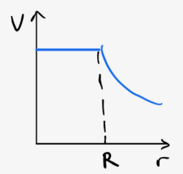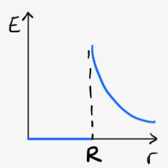
… for positive charge. If charge is negative then reflect across x-axis
Integral of e-field is electric potential difference, not work
Electrostatic shielding - a conductor between a uniform electric field, space inside the conductor has 0 electric field (faraday’s cage)
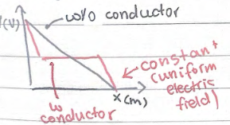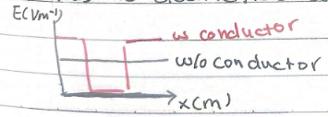

Circular Motion
Same equations as kinematics, just $x$ is replaced with $θ$, $v$ replaced with $ω$, $a$ replaced with $α$
Angles are vectors, direction is positive for counterclockwise, negative for clockwise.
Same graph as kinematics (except with corresponding dependent variables for angular)
Tangential velocity, always perpendicular to radius:
$s=r⋅radianθ$, hence $v_{t}=r⋅ω$, $a_{t}=r⋅α$
Centripetal acceleration ($\left|v_{t}\right|$ is constant but ${\vec{v}}_{t}$ is not, directional change). Always points inwards. In system of forces, $F_{net}=m×a_{c}$, hence related to net force.
Horizontal circular motion (string must be at an angle due to gravity, hence $F_{T}$ points upwards too). Use $r=R⋅cosθ$ (for $r$ is path radius, $R$ is string length). Separate into vertical horizontal components and use $\frac{F_{net, x}}{F_{net, y}}$ to cancel out $F, m$, etc. => $v=\sqrt{\frac{g⋅r}{tanθ}}$
Hidden cases of circular motion:
car climbing over hill, drum ride, rollercoaster loop, car on curve, banked curves (min. velocity is when a certain force, e.g. normal force, reaches zero). When constant velocity is not guaranteed, use conservation of energy to obtain initial speed required.

Gravitational Force
$\left|\vec{F}\right|=-G\frac{m_{1}⋅m_{2}}{r^{2}}$, for $G=6.67×10^{11}N m^{2}kg^{-2}$ in vacuum (they are negative! hence always inwards to center)
Decompose vectors similar to electric
$g=\frac{F_{g}}{m}=-\frac{G⋅M}{r^{2}}$, field strength
$E_{p}=-G⋅\frac{M⋅m}{r}$, $V_{g}=\frac{ΔE_{p}}{m}=\frac{W}{m}=-\frac{G⋅M}{r}$
Same graphs as electric force/field/energies, except they are reflected across x-axis.
Uniform gravitational field when large $r$ and at surface (e.g. Earth, $9.8m s^{-2}$)
Graphical interpretations, $W=ΔV⋅m$, hence work done from moving charge from point A to B is gotten by change in Voltage (not voltage alone). When asked to graph, pay attention to mass’s radius (jump discontinuity).
For two mass graphs, larger mass asymptote extends further from center, smaller mass asymptote does not extend far (weaker effect) $g=-\frac{dV}{dr}$ also applies. The maximum of the graph reflects point of equilibrium, $g_{A}=g_{B}$, $\frac{A}{B}=\frac{{r^{2}}_{A}}{{r^{2}}_{B}}$, ratio between masses. Point of eqm is also reflective of minimum work (you only have to do work until gravity helps)
Gravitational force is a centripetal force, obtain velocity from centripetal force definition gives $v=\sqrt{\frac{G⋅M}{r}}$ where $v=\frac{2πr}{T}$ for $T^{2}=\frac{4π^{2}}{G⋅M}⋅r^{3}$
Escape velocity (speed), minimum speed required so projectile no longer falls down again. Occurs when $E_{k, final}=E_{p, final}=0$ for initially $E_{k, initial}>0$, $E_{p, initial}<0$. Hence $\frac{1}{2}mv^{2}+(-\frac{G⋅M⋅m}{r})=0$, $v=\sqrt{\frac{2⋅G⋅M}{r}}$

Since $E_{p}<0$ while $E_{k}>0$, total energy $E_{T}=E_{p}+E_{k}$ for $E_{k}=\frac{1}{2}mv^{2}=\frac{1}{2}m⋅(\frac{G⋅M}{r})=\frac{1}{2}\frac{G⋅M⋅m}{r}=\frac{1}{2}E_{p}$. Hence $E_{T}=-E_{k}$
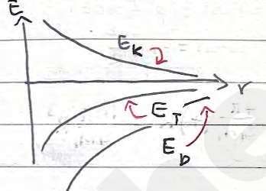

When $E_{T}<0$, circular/elliptic orbit; $E_{T}=0$, parabolic orbit; $E_{T}>0$, hyperbolic orbit
Binary orbit system, two bodies orbit each other (motion affects each other). Start with gravitational=centripetal $F_{grav}=-G⋅\frac{m_{1}⋅m_{2}}{r^{2}}$ and $F_{c}=-M_{2}⋅\frac{v^{2}}{R}$. Hence, $v^{2}=\frac{G⋅M_{1}}{4R}$ and $T^{2}=\frac{16π}{G⋅M_{1}}R^{3}$.

Electricity
In uniform electric field, most electrons probabilistically move to positive (they don’t move linearly due to electron-electron repulsion and electron-nucleus attraction)
Current is opposite to flow of electrons $I=\frac{Δq}{Δt}$ in $A=C s^{-1}$.
Resistance, repulsive and resistive forces against electrons: $V=IR$
For ohmic materials $R$ constant so $V(I)=IR$. For non-ohmic, this relationship doesn’t hold $V=IR$ still applies but $I$-$V$ non linear. (Note, typically I vs V is graphed, hence slope is $\frac{1}{R}$)
Circuits are composed of resistors, diodes, capacitors, coil/inductors, transistors
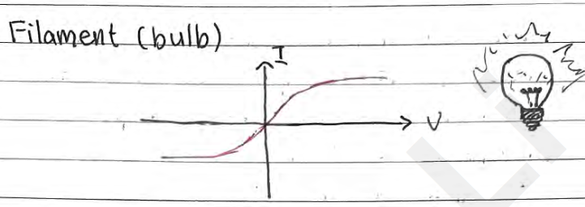
$R=ρ⋅\frac{L}{A}$, resistance depends on length $L$, cross-sectional area $A$, $ρ$ resistivity of material.
Electrical conductivity is $\frac{1}{R}$
As temperature increases, so does resistance. However, at values close to zero temperature, resistance jumps to 0 (superconductor, efficient)

Electric circuit - transfer of energy from source to consumer. Transfer occurs with potential difference created by battery
Electric circuit symbols 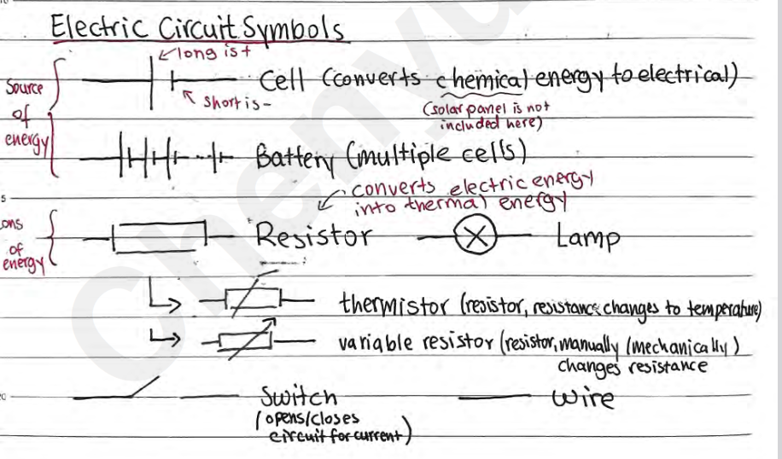
In an open circuit, I=0
Resistors in series $R_{equivalence}=ΣR_{i}$, $V_{total}=ΣV_{i}$, $\frac{1}{I_{total}}=Σ\frac{1}{I_{i}}$. Hence $\frac{V_{1}}{V_{2}}=\frac{R_{1}}{R_{2}}$

Resistors in parallel $R_{equivalence}=Σ\frac{1}{R_{i}}$, $I_{total}=ΣI_{i}$, $\frac{1}{V_{total}}=Σ\frac{1}{V_{i}}$. Hence $\frac{I_{2}}{I_{1}}=\frac{R_{1}}{R_{2}}$
Electric power $P=I^{2}⋅R=\frac{V^{2}}{R}=IV$
Ideal Ammeters have negligible resistance, Ideal Voltmeters have infinite resistance (Useful when analyzing complex electrical circuits with these instruments in them)

Thermistor - Temperature dependent resistance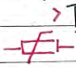
Light dependent resistor - Intensity of light dependent resistance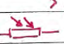
Potentiometer - Length dependent resistance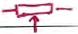

Electromotive Force (Emf), energy. Work done per unit charge in moving a charge from one terminal of the battery to the other
Voltage of an ideal battery and voltage of real when current = 0. In a real battery there’s internal resistance, hence measured voltage is lower than emf

Buoyant Force
Upward force exerted by fluid that opposes weight of immersed object
$F_{B}=ρ_{fluid}⋅V_{object}⋅g$ for $F_{B}$ is Buoyant force, $ρ_{fluid}$ is density of surrounding fluid, $V_{object}$is volume of the object, $g$ is the acceleration due to gravitational force
Viscous drag force $F_{D}$, stems from drag force from object’s movement in a fluid. For a spherical object (at constant velocity)...
$F_{D}=6⋅π⋅η⋅r⋅v$, $F_{D}$ is viscous drag force, $η$ is viscosity, $r$ is sphere radius and $v$ is velocity of motion.
Millikan’s oil drop experiment:
Oil drops ionized (-) and dropped into parallel plates
When parallel plates are inactive, drops free fall at terminal velocity such that $F_{D}+F_{B}=F_{g}$, hence $r=\sqrt{\frac{9}{2}⋅\frac{η⋅v}{g⋅(ρ_{oil}-ρ_{air})}}$. Helps determine radius of oil droplets
When active parallel plates, drops remain static where $F_{B}+F_{E}=F_{g}$, $q=\frac{d}{v}⋅g⋅\frac{4}{3}πr^{3}(ρ_{oil}-ρ_{air})$

Rotational Dynamics
Dynamics deal with why objects move. In linear, object accelerates from force. In angular, object angularly accelerates from torque.
Torque - Ability of a force to rotate a body (moment of a force)
$τ_{net}=I⋅α$ for $I$ is moment of inertia
$\left|\vec{τ}\right|=\left|\vec{r}\right|⋅\left|\vec{F}\right|⋅sinθ$.
Couples are pairs of equal and opposite coplanar forces, their directions pointing around the center of rotation allows for $τ_{net}=2⋅τ$
Rotational equilibrium is when $τ_{net}=0$
Rotational Kinetic Energy
Sum of particle kinetic energies make up body’s kinetic energy, hence…
$E_{k}=\frac{1}{2}I⋅ω^{2}$ for $I=Σ(m_{i}{{⋅r}_{i}}^{2})$
Rolling without slipping (rolls without sliding). Total kinetic energy is the sum between ${E_{tot.}=E}_{k, trans.}+E_{k, rot.}=\frac{1}{2}mv^{2}+\frac{1}{2}Iω^{2}$. $v_{trans.}=v_{tang.}=r⋅ω$ hence $E_{k}=\frac{1}{2}v^{2}(m+\frac{I}{r^{2}})$. When rolling without slipping, total energy is conserved. (Total initial = total final where initial typically involves gravitational potential energy)

For non-massless Atwood’s Machine, rotational dynamics should be analyzed (Tension is not same across ends)

Angular momentum, $F_{net}=\frac{Δp}{Δt}$ and thus $τ_{net}=\frac{ΔL}{Δt}$.
Impulse would be $J=F_{net}⋅Δt=Δp$ and hence $J_{angular}=τ_{net}⋅Δt=ΔL=Δ(I⋅ω)$.

Other formulas include $P=\frac{W_{rot}}{t}=τ⋅ω$, $W=τ⋅θ$, $E_{k}=\frac{L^{2}}{2I}$
Area beneath $τ$-$θ$ graph is work, area beneath $τ$-$t$ is impulse. Maximum force occurs when there is maximum torque for the same radius.

For rotational dynamics problems, set the center of rotation as the one with the most unknowns (as they cancel out). Additionally, make sure to consider ALL forces, including friction, normal, and any reactive forces. Typically, translational equilibrium ($F_{net}=0$) and rotational equilibrium ($τ_{net}=0$) is reached.
Angular momentum is conserved for collisions too. This occurs when there is a change in mass distribution (e.g. masses on a rod, rod is extended) or a translational movement is introduced (e.g. a projectile launched at a spinning disc). In these cases, use angular momentum initial and final, taking into account the final positions of bodies and their respective momentums.

Magnetism
Directions are North and South (North field lines point outwards into South). A magnet (even will split) will still have the two poles.
Since compasses align their direction based on earth’s field, Earth’s north pole is magnetically south, and vice versa.
Magnetic field induced when current exists (use right hand rule, thumbs up)
$B∝\frac{1}{r}$, further away from wire, weaker magnetic field
Electromagnetic works when wires curled up into coil (right hand rule also works, with fingers indicating direction of current, thumb indicating magnetic field)
Magnetic field is represented with “x” (into page) and “.” (out of page) in 3D
Magnetic force is attractive between parallel wires of the same current direction, repulsive when different: $\frac{F}{L}=\frac{μ_{0}⋅I_{1}⋅I_{2}}{2π⋅r}$ where $μ_{o}=4π×10^{-7}N A^{-2}$ refers to permeability of free space, $L$ is length of wire. With more than two parallel wires, do vectorial addition/subtraction

Magnetic force on moving charge $F=q⋅v⋅B⋅sinθ$. Direction of force can be found with left-hand rule (thumb = force, index = magnetic field, middle = velocity). Since force is always perpendicular to velocity, particles will move in circular motion. $r=\frac{m⋅v}{q⋅B}$ for $r$ is radius of circular motion. Used in mass spectrometer $\frac{m}{q}∝r$
When velocity is not perpendicular to magnetic field, only use perpendicular component of magnetic field.

Ampere - Current in two 1m wires that are 1m apart with equal currents where the force on them is $2⋅10^{-4}N$
With radius to mass-charge equation… $E_{k}=\frac{p^{2}}{2m}$, $r=\frac{p}{qB}=\frac{\sqrt{2E_{k}m}}{qB}$ and hence $r∝\sqrt{E_{k}}$/ Thus, kinetic energy stays constant in this kind of circular motion
$qV=E_{k}=\frac{1}{2}mv^{2}$, when paired with $\frac{q}{m}=\frac{v}{rB}$ yields $\frac{q}{m}=\frac{2V}{r^{2}B^{2}}$ and hence $B^{2}=\frac{2m}{qr^{2}}V$.

When magnetic field and electric field is combined together such that forces cancel out on charge, a velocity selector is formed: $F_{E}=F_{M}$ for $v=\frac{E}{B}$

Moving charges in a uniform electric field result in a force (opposite for particle charge), hence positive and negative charges are separated, inducing emf
Motional emf: $ξ=vBL$
emf is defined as $ξ=-\frac{ΔΦ}{Δt}$ for magnetic flux $Φ=B⋅A⋅cosθ$. So when there is a change in magnetic flux (amount of magnetic field lines passing through surface area), emf is induced. This can occur with a rotating magnet (hydroelectric power plant). Total energy is gotten from electric power $P=\frac{ξ^{2}}{R}$
For a coil of N loops, $ξ=-\frac{Δ(N⋅Φ)}{Δt}$
Lenz’s law - Induced emf will always act to oppose the change producing it. Hence, obtain direction of magnetic flux change, get the opposite and obtain the electric current related to that opposite direction.

AC generators, rotating loop changes $\vec{A}$(area), $Φ$ and inducing $ξ$
Since rotational loops alternate periodically between positive and negative, magnetic flux and emf are sinusoidal.
$Φ=BAcos(ωt)$, $ξ=ωNBAsin(ωt)$, $P=\frac{ξ^{2}}{R}=\frac{(-ωNBA)^{2}}{R}\sin^{2}(ωt)$
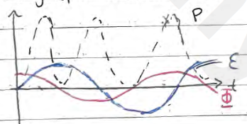
Self-induction - Induced emf can arise from single coils or solenoid (changes in current applied to voltage changes, opposing change occurs from induced current. A sudden change in flux induces emf.

Nuclear Physics
${}_{Z}^{A}X$ denotes an atom of atomic number $Z$, atomic mass/nucleon $A$
$n^{0}=A-Z$
Isotopes are same elements but of different number of neutrons
Hydrogen isotopes:${}_{1}^{1}H$ (hydrogen), ${}_{1}^{2}H$ (detereum), ${}_{1}^{3}H$ (tritium)
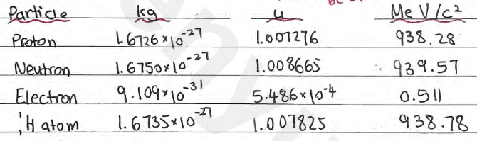
where MeV/c² comes from $eV=Energy=mc^{2}$

Binding energy (mass loss through exothermic bond creation)
$p_{mass}^{+}+n_{mass}^{0}>Nucleus_{mass}$
Mass defect is $(Protons+Neutrons) - Nucleus$, this denotes mass loss which is released through energy $ΔE=Δm⋅c^{2}$
Binding energy per nucleon follows the following trend:
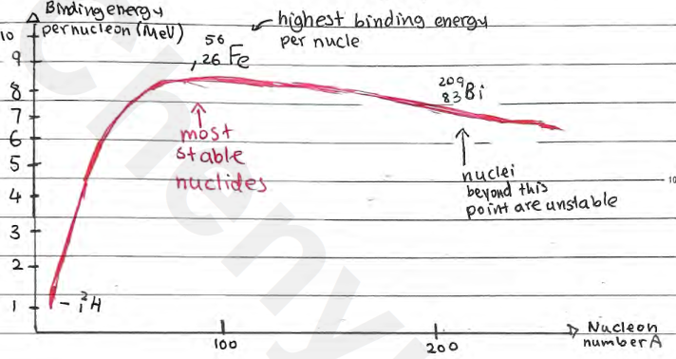
Nuclear stability depends on number of protons with neutrons. It deviates from 1:1 ratio since more neutrons per proton as number of protons increase.
Attractive force within nucleus to overcome electrostatic repulsion is Strong Nuclear force (only acts within nucleus, too many neutrons make nucleus too large and thus Strong Nuclear Force weak, unstable)

Radioactivity: $n^{0}→p^{+}+e^{-}$ (conversion between subatomic particles)
Alpha radiation - release of particles, including ${}_{2}^{4}He$ (alpha particle)
Highly ionizing (2+ charge), penetrate matter poorly, absorbed by a few cm of air/thin sheet of paper
${}_{Z}^{A}X→{}_{Z-2}^{A-4}Y+{}_{2}^{4}He$
Beta radiation - release of particles, including ${}_{-1}^{0}e$ (electron) or ${}_{+1}^{0}e$ (anti-electron)
Moderate ionizing power, moderate ability to penetrate matter, absorbed by 25cm of air, few cm of tissue, few mm of aluminum
${}_{Z}^{A}X→{}_{Z-1}^{A}Y+{}_{-1}^{0}e+{}_{0}^{0}\underline{v}$ (${}_{0}^{0}\underline{v}$ is antineutrino, to balance energy)
${}_{Z}^{A}X→{}_{Z-1}^{A}Y+{}_{+1}^{0}e+{}_{0}^{0}v$ (${}_{0}^{0}v$ is neutrino, to balance energy)
Gamma radiation - release of gamma electromagnetic waves (high energy photons)
All decays are random (any particle can decay) and spontaneous (can happen any time), they follow energy conservation.
Weakly ionizing, eject electrons from metals (photoelectric effect), highly penetrating, few cm of lead, few m of concrete, weakly absorbed by animal tissue
${}_{Z}^{A}X*→{}_{Z}^{A}X+{}_{0}^{0}γ$, ${}_{Z}^{A}X*$ refers to excited parent nucleus, ${}_{Z}^{A}X$ is de-excited daughter nucleus
Radiation can be distinguished in a magnetic field due to deflections based on charge

Radioactive Decay Law, rate of decay proportional to number of nuclei not decayed yet
$\frac{dN}{dt}=-λN$ logistic differential equation, for $λ$ is decay constant
$N=N_{0}e^{-λt}$ (gives # of nuclei undecayed at given time), $N_{0}$ is total nuclei
On a graph, decayed and undecayed nuclei at given time are complementary
Rate of decay is also activity, $A=-\frac{dN}{dt}=λN=λN_{0}e^{-λt}=A_{0}e^{-λt}$, unit is Becquerel (Bq).
Half-life is $T_{1/2}=\frac{ln2}{λ}$. On a graph, it’s reflected as time when $\frac{N_{0}}{2}$. Sample is continuously halved for each $k T_{1/2}$.
A real-life decay graph has background noise, hence the asymptote is not at zero. Half life must be adjusted to account (it’s time required for sample excluding noise to halve)

Transmutation - Transformation of one element into another. When a nucleus is struck by another nucleus, neutron, or gamma ray.
Nuclear reactions, these reactions follow conservation of particles, where # nucleons and # protons is conserved.

Reaction energy, energy change during nuclear reactions. Can be calculated from mass difference $-Δm$ or binding energy $ΔBE$ (make sure to multiply by # of nucleons) (single-particles e.g. hydrogen/proton, neutron lack BE)
Exothermic, Q>0, mass decrease. Endothermic, Q<0, mass increase.
Fission - large nuclei split apart
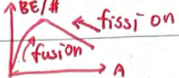
Fusion - small nuclei join together
A reaction occurs when the minimum energy is met (find Q of reaction and determine whether initial kinetic energy meets that). Both can technically occur naturally and induced, though natural fission is insanely rare.
Both fission and fusion are exothermic, on different portions of BE/nucleon - A graph.
